Single Motor Double Door Opener Mechanism

Many large size entrances in halls, rooms, malls, corridors use double doors. Now like other doors double doors cannot be easily automated since both doors need to be opened at once. Use of 2 motors for each door has 2 problems:
- Coordinated opening of booth doors
- High cost of 2x motors

So here we design a solution to this problem using a single motor double door opener mechanism. This mechanism solves both problems as both doors open at the same time in coordination as well as the system is cheaper as only one motor is used.

The motor is integrated with a shaft design which has a linkage mechanism attached to it. The shaft rod of the motor is now connected to 2 different linkages at a perpendicular angle. These two linkage rods are now connected to the doors through a rotating L angle.

Thus then the geared motor shaft rotates the rod drives 2 other connected rods in linkage who in turn open both the doors at the same time and speed. Similarly when motor rotates in opposite direction, both doors close parallely at same speed.

Thus we successfully design a low cost and well coordinated double door opening and closing mechanism.

Components

- Geared Motor
- Shaft Rod
- Motor Mount
- Connecting Rods
- L Angles
- Mounts and Joints
- Supporting Frame
- Screws and Bolts

Advantages

- Coordinated Door Opening
- Same Speed Door Opening
- Low Cost Mechanism

Disadvantages

- Requires installation on Ceiling

Block Diagram
Top View

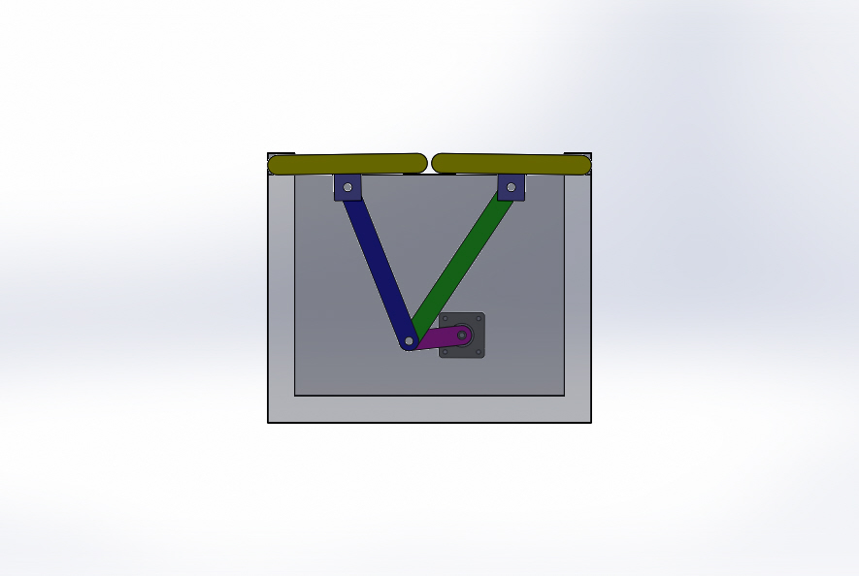
Front View
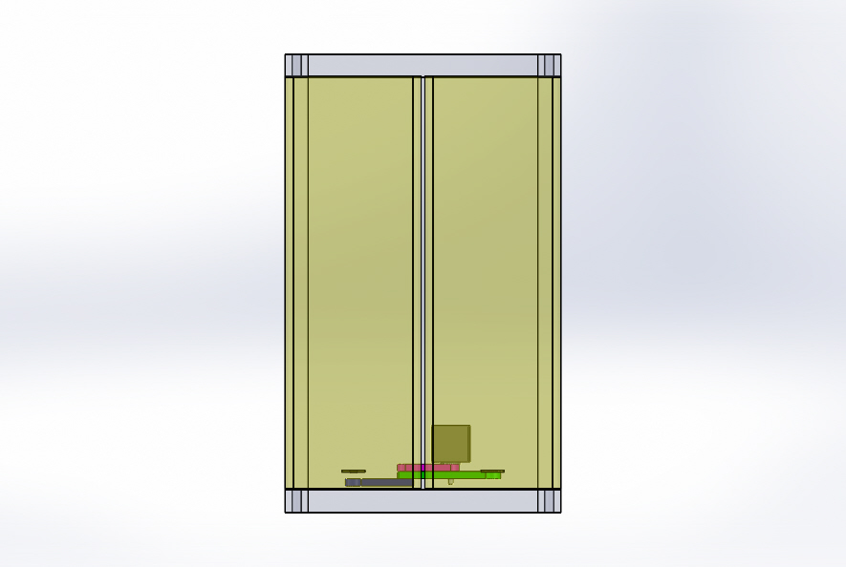

3D View

